Trendstore Application deployment

1.Terraform (Provisioning the Infrastructure):
A.) Providers Block:
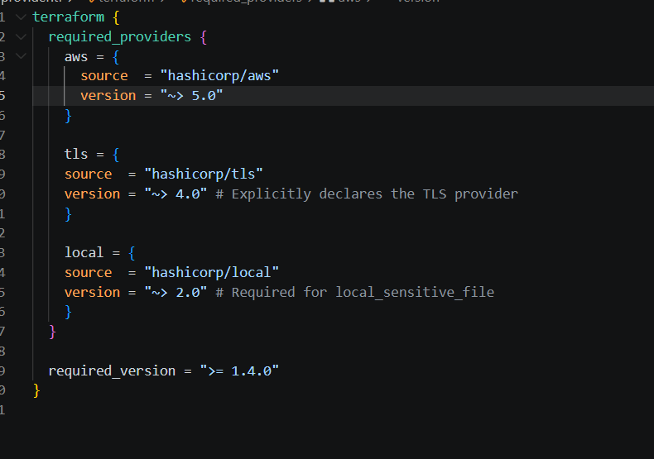
B.)Resources Block:
a.) VPC
b.) Subnet
c.)Internet Gateway
d.) Route table
e.) Route table Association
f.) Private Key (Module tls)
g.) Security Groups
h.) Ec2 instance (With Nginx,Docker,Jenkins using Userdata)
i.) KeyPair
j.)Local sensitive File for copying keypair to Machine (Module local)
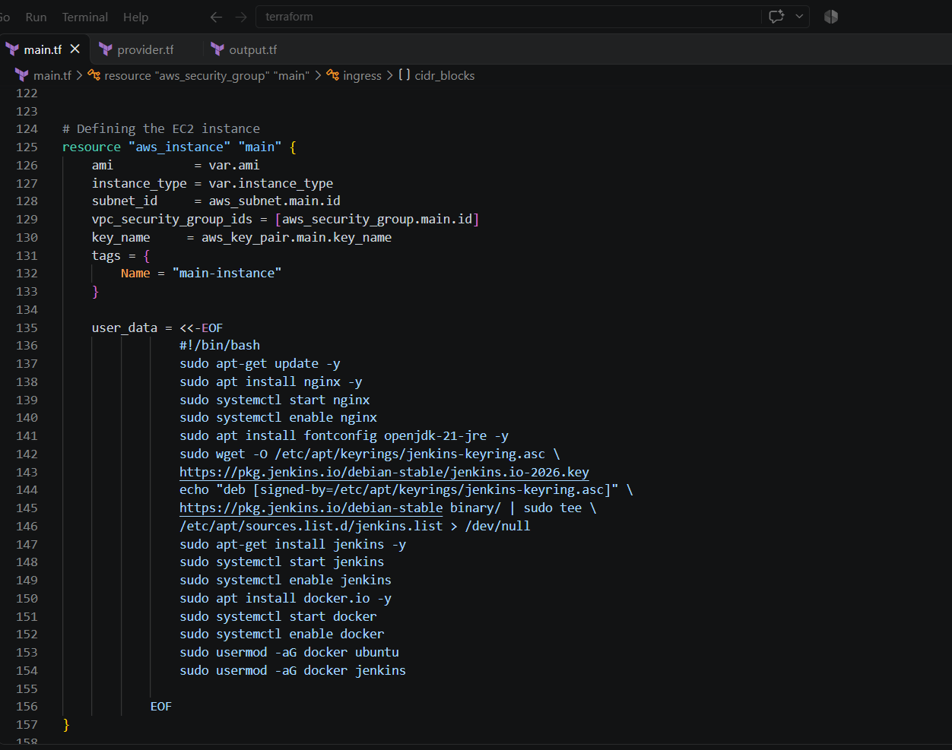
C.)Output Block:
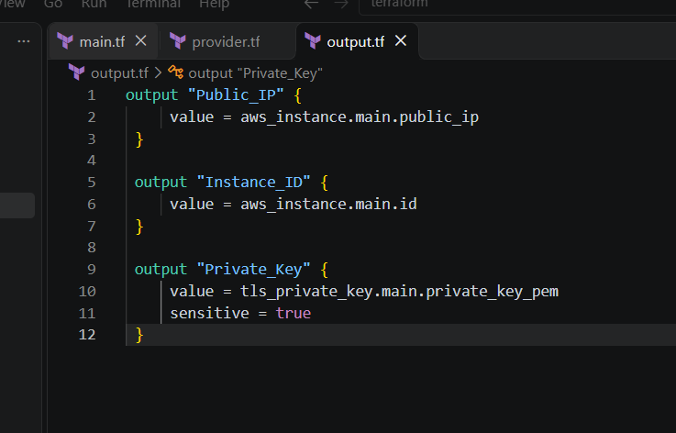

Use Terraform workspaces to create separate workspace
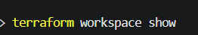
Use terraform commands to create resources on the aws with AWs CLI.
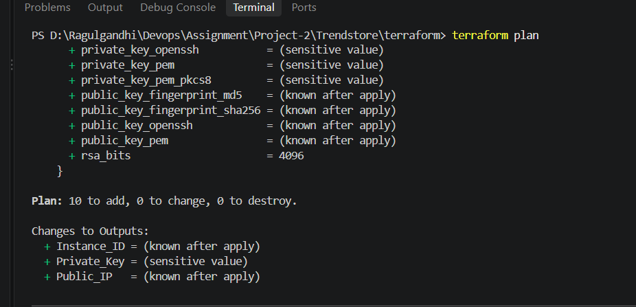
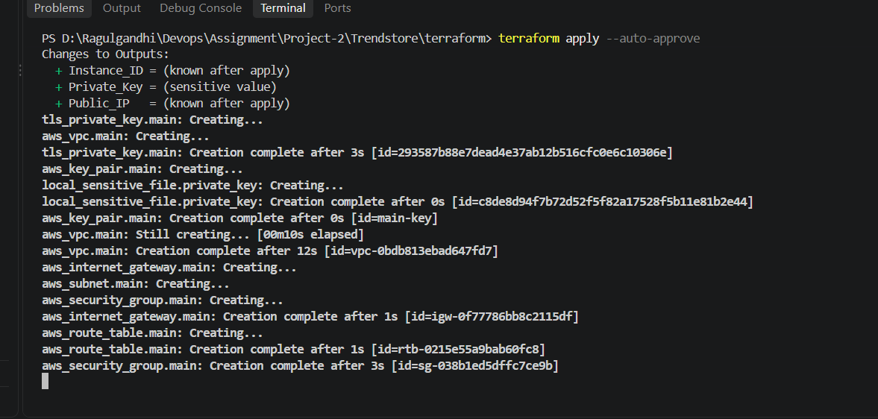
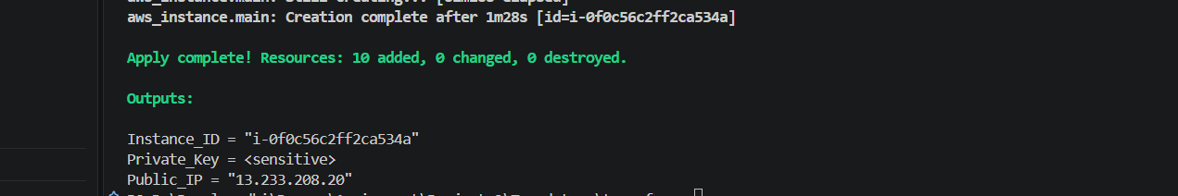
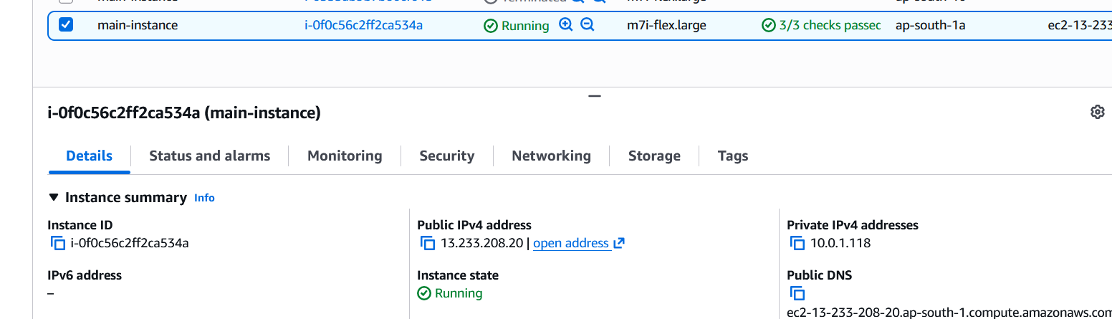

Ec2 instances created with Jenkins,Docker and Nginx installed
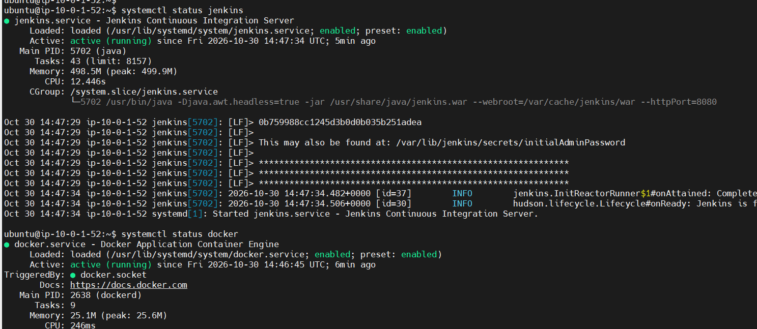
2.Docker(Containerization of application):

Clone the application to the machine
Create a docker file and run the application using below commands.
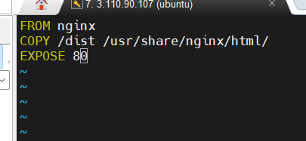

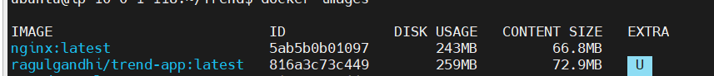
Map the port 8081 to expose the application.


Push the image to the Docker HUB.

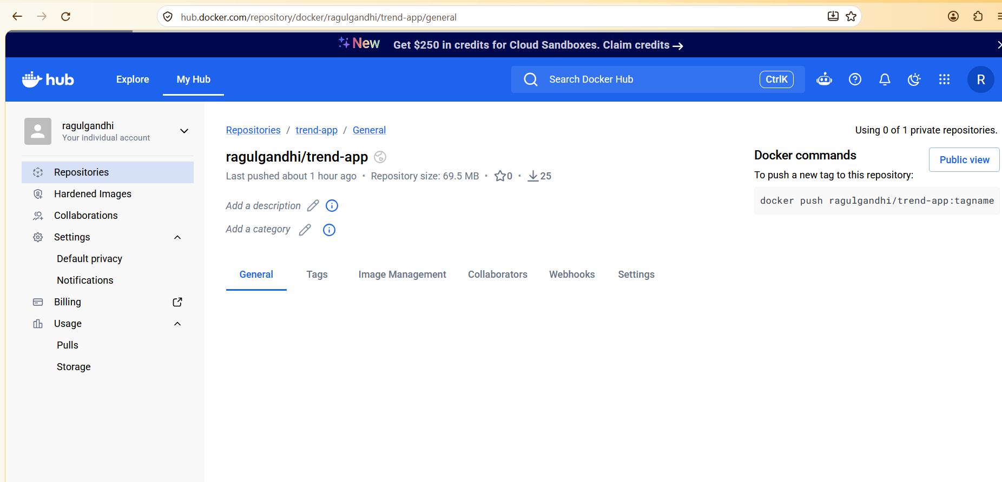
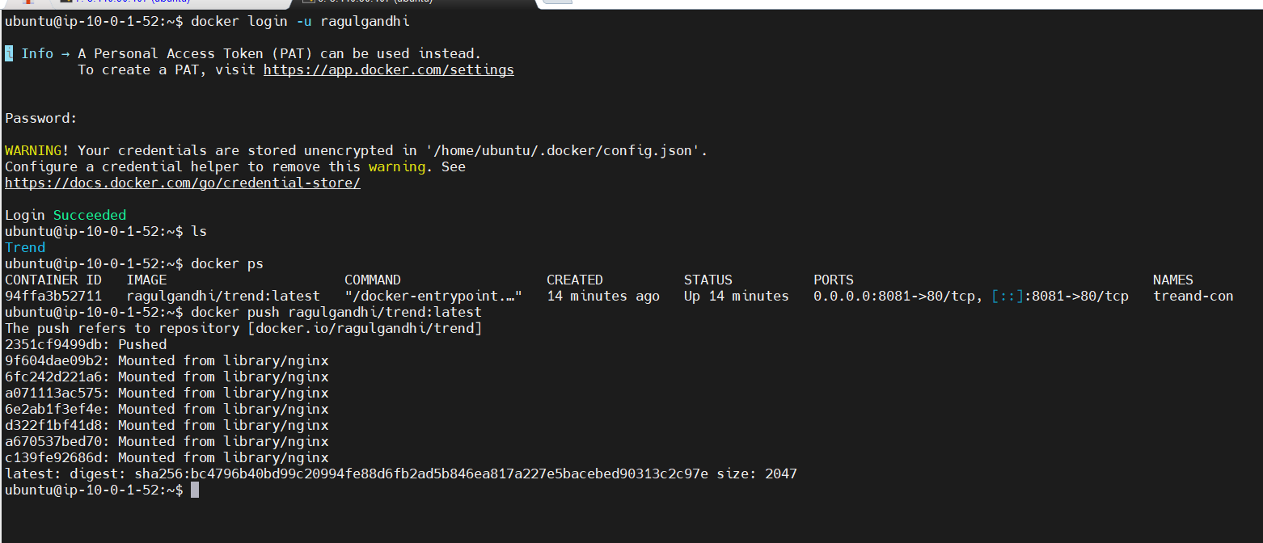
3.Kubernetes:
Install Kubectl and Eksctl for managing and creating Kubernetes objects.

Kubectl:

curl -LO "https://dl.k8s.io/release/$(curl -L -s https://dl.k8s.io/release/stable.txt)/bin/linux/amd64/kubectl"

chmod +x ./kubectl

sudo mv ./kubectl /usr/local/bin

Eksctl:
curl --silent --location "https://github.com/weaveworks/eksctl/releases/latest/download/eksctl_$(uname -s)_amd64.tar.gz" | tar xz -C /tmp

sudo mv /tmp/eksctl /usr/local/bin

Awscli:
sudo apt install zip -y
curl "https://awscli.amazonaws.com/awscli-exe-linux-x86_64.zip" -o "awscliv2.zip"
unzip awscliv2.zip
sudo ./aws/install

Create Cluster using eksctl:
Verify the cluster and nodes created:
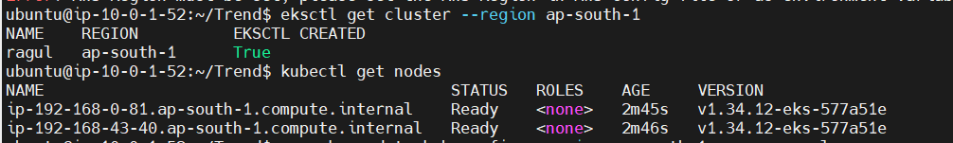

Create a manifest file for the application with service and deployment objects:
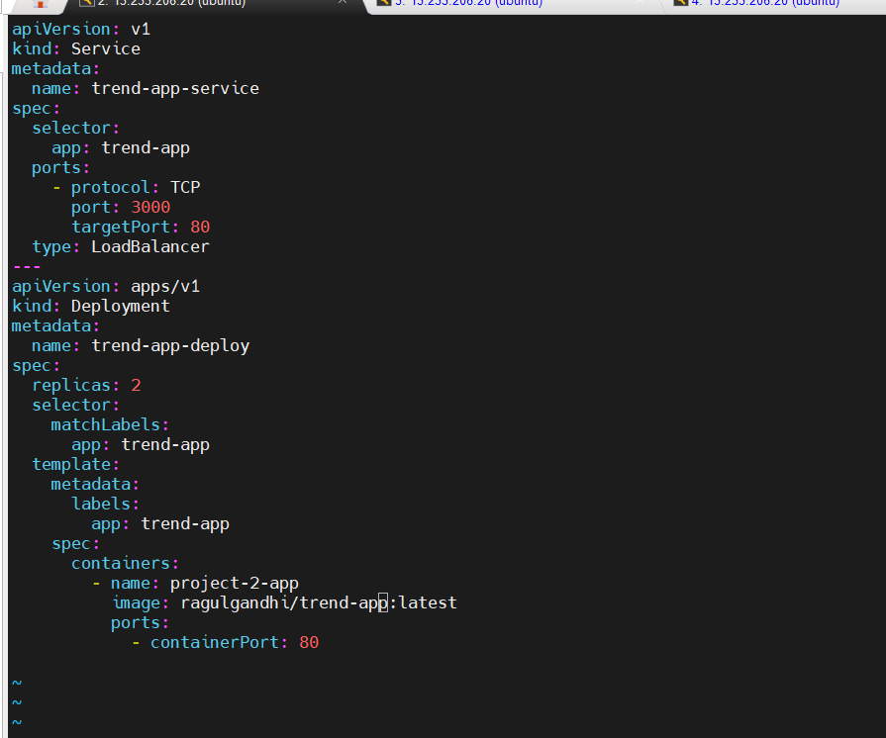
Deploy the manifest file and verify the Pods and service created.

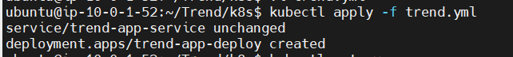
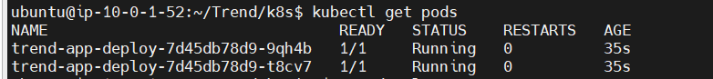
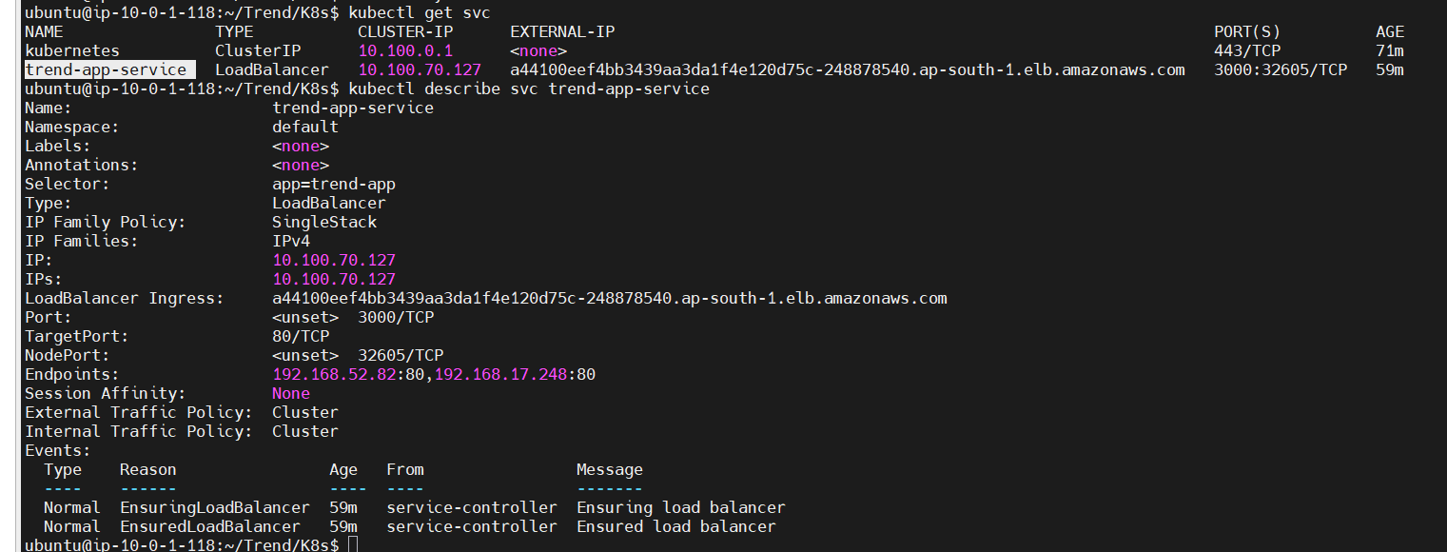
Verify the application deployed on the kubernetes cluster using loadbalancer ingress:
Application deployed ARN:
http://a44100eef4bb3439aa3da1f4e120d75c-248878540.ap-south-1.elb.amazonaws.com:3000/


4.Observability using Prometheus and Grafana:

Install Helm for managing packages inside K8s by following commands.
HELM_BUILDKITE_APT_KEY_ID="DDF78C3E6EBB2D2CC223C95C62BA89D07698DBC6"

sudo apt-get install curl gpg --yes

curl -fsSL https://packages.buildkite.com/helm-linux/helm-debian/gpgkey > "${TMPDIR:-/tmp}/helm.asc"

# Ensure that the key ID matches to prevent a repository compromise from establishing an attacker controlled key
if [ "$(gpg--import--import-options=show-only--with-colons"${TMPDIR:-/tmp}/helm.asc" \
| awk -F: '$1 == "fpr" {print $10}' | head -n 1)" != "${HELM_BUILDKITE_APT_KEY_ID}" ]; then
echo "ERROR: Unexpected Helm APT key ID: potential key compromise"
exit 1
fi

# Remove configuration left by earlier versions of these instructions
sudo rm -f /etc/apt/sources.list.d/helm-stable-debian.list /usr/share/keyrings/helm.gpg

sudo install -m 0644 -Dt /etc/apt/keyrings/ "${TMPDIR:-/tmp}/helm.asc"

sudo tee /etc/apt/sources.list.d/helm-stable-debian.sources > /dev/null <<EOF
Types: deb
URIs: https://packages.buildkite.com/helm-linux/helm-debian/any/
Suites: any
Components: main
Signed-By: /etc/apt/keyrings/helm.asc
EOF

sudo apt-get update
sudo apt-get install helm

Once helm is installed,use helm charts for Prometheus-Grafana-Alert manage stack repo.

helm repo add prometheus-community https://prometheus-community.github.io/helm-charts helm repo update
kubectl create namespace monitoring
helm install monitoring prometheus-community/kube-prometheus-stack --namespace monitoring

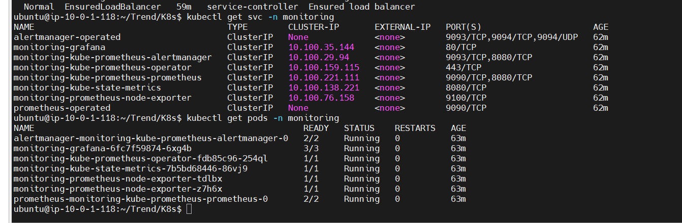
USe Port Forward method to expose both grafana and Prometheus.

kubectl port-forward -n monitoring svc/monitoring-grafana 3000:80 --address 0.0.0.0
kubectl port-forward -n monitoring svc/monitoring-kube-prometheus-prometheus 9090:9090 --address 0.0.0.0

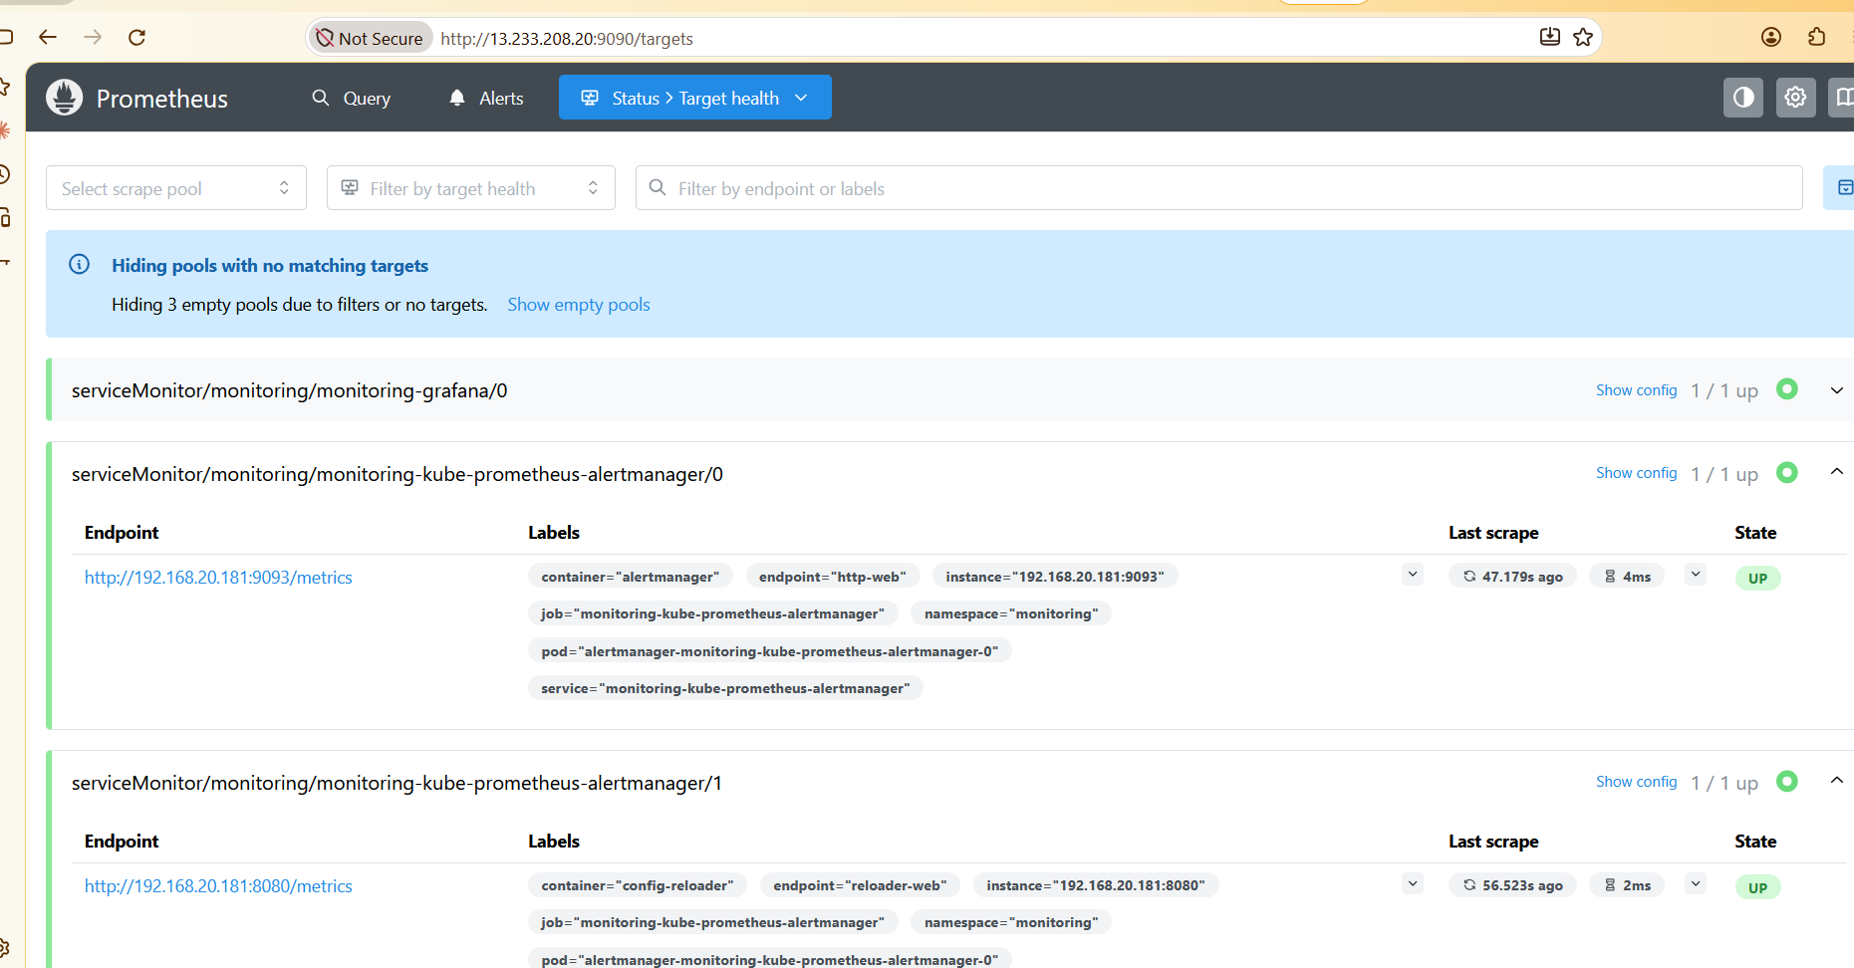

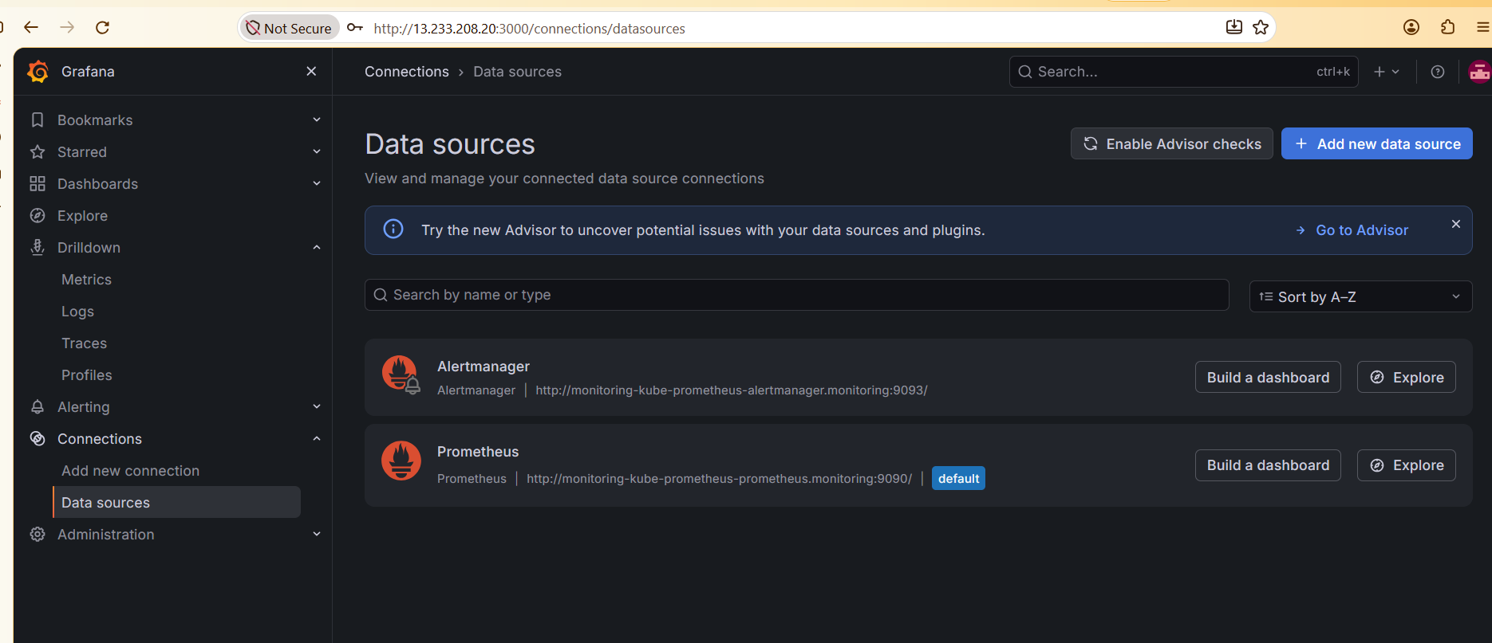

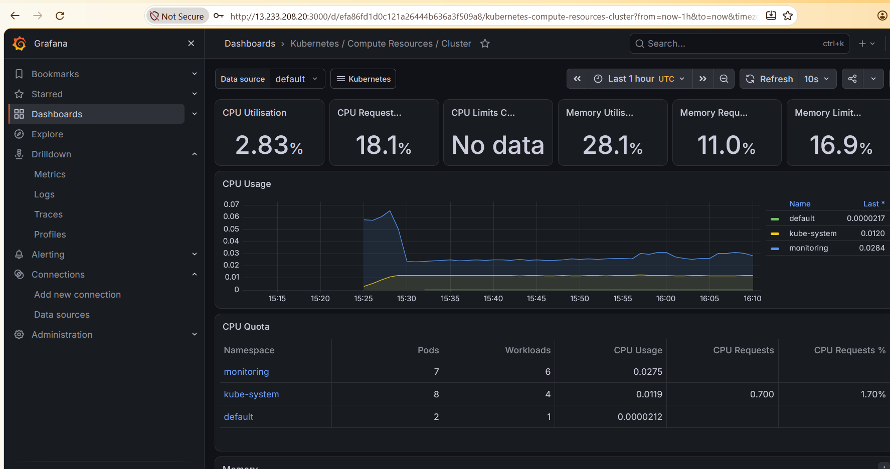

Kindly set the pipeline with Jenkinsfile.
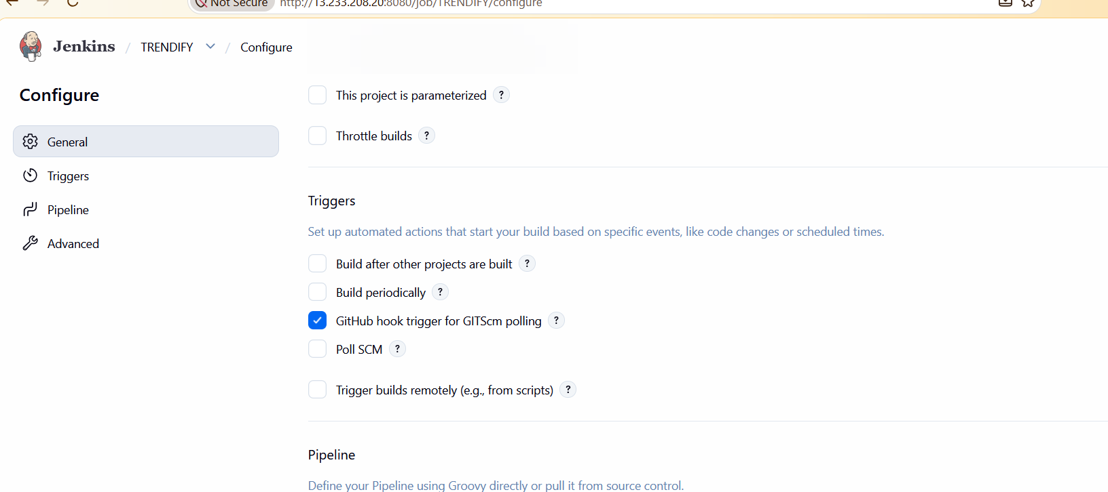
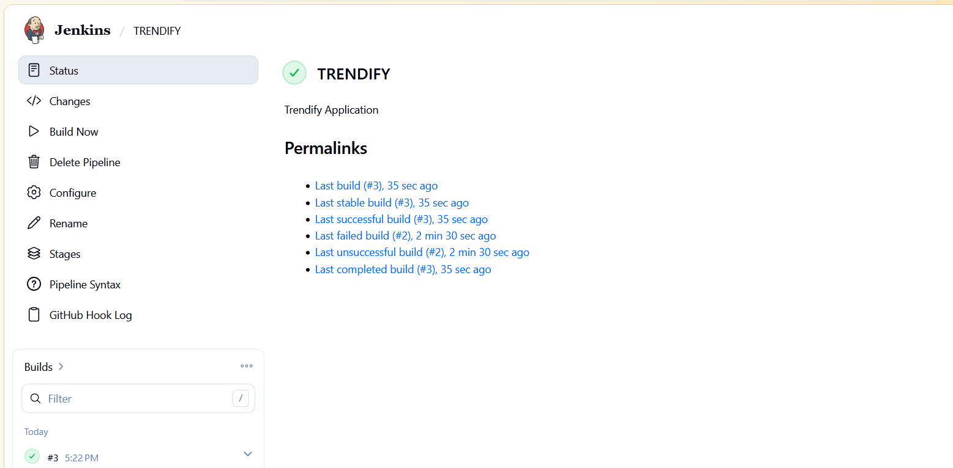
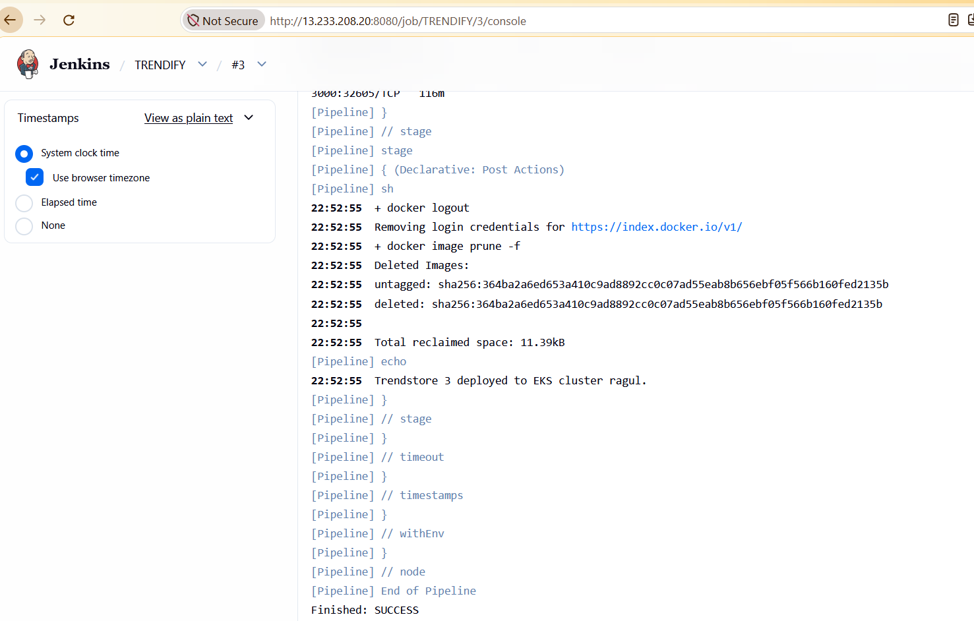
Finally add Webhook for the URL to set the pipeline automatic when commit is made.
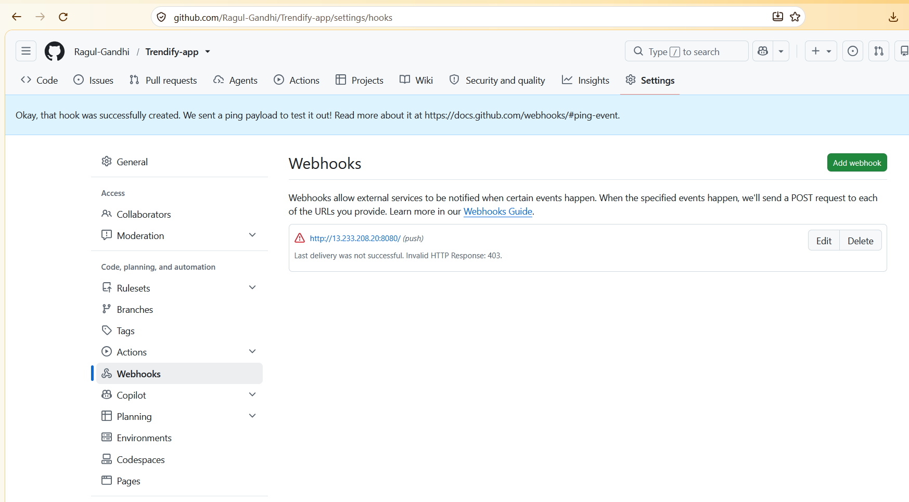

To verify the build,changing the base image as nginx:alpine


